**Task 1:**

**1: Install Jupyter notebook and run the first program and share the screenshot of the output.**

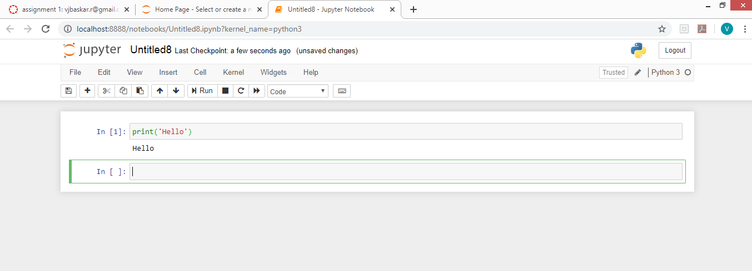

**2. Write a program which will find all such numbers which are divisible by 7 but are not a multiple**

**of 5, between 2000 and 3200 (both included). The numbers obtained should be printed in a**

**comma-separated sequence on a single line.**

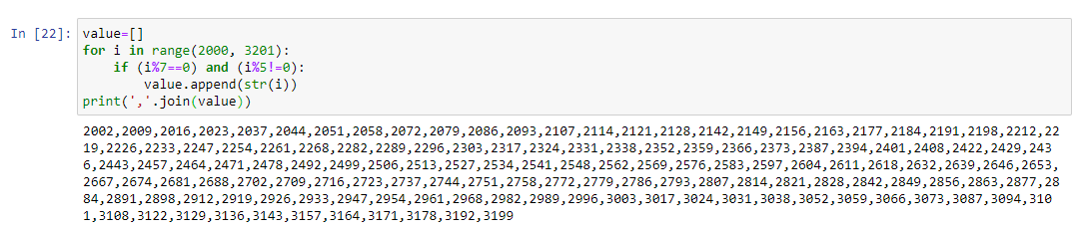

**3. Write a Python program to accept the user's first and last name and then getting them printed in the reverse order with a space between first name and last name.**

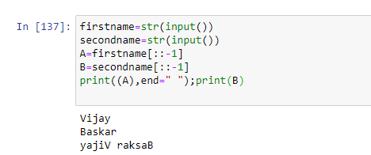

**4. Write a Python program to find the volume of a sphere with diameter 12 cm.**

**Formula: V=4/3 * π * r 3**

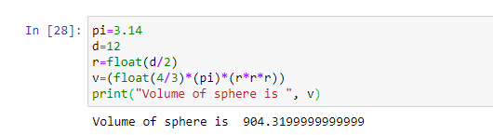

**Task 2:**

**1. Write a program which accepts a sequence of comma-separated numbers from console and generate a list.**

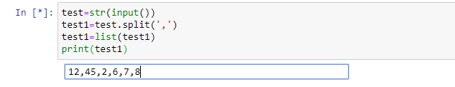

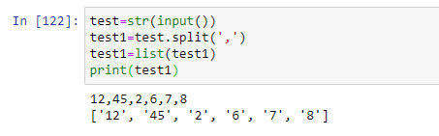

**2. Create the below pattern using nested for loop in Python.**

**\***

**\* \***

**\* * \***

**\* * * \***

**\* * * * \***

**\* * * \***

**\* * \***

**\* \***

**\***

**Solution:**

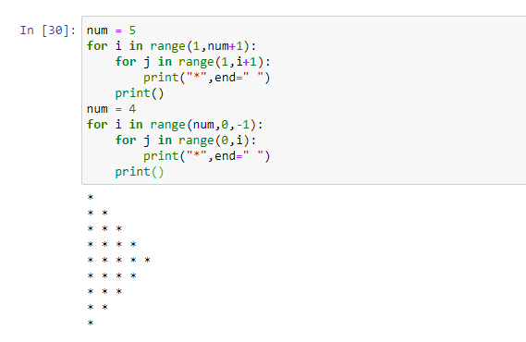

**3. Write a Python program to reverse a word after accepting the input from the user.**

**Sample Output:**

**Input word: AcadGild**

**Output: dilGdacA**

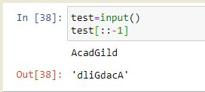

**4. Write a Python Program to print the given string in the format specified in the sample output.**

**WE, THE PEOPLE OF INDIA, having solemnly resolved to constitute India into a**

**SOVEREIGN, SOCIALIST, SECULAR, DEMOCRATIC REPUBLIC and to secure to all its citizens**

**Sample Output:**

**WE, THE PEOPLE OF INDIA,**

**having solemnly resolved to constitute India into a SOVEREIGN, !**

**SOCIALIST, SECULAR, DEMOCRATIC REPUBLIC**

**and to secure to all its citizens**

